Spring MVC Architecture
Spring MVC (Model-View-Controller) is a popular framework within the Spring ecosystem used to build web applications. It follows the Model-View-Controller design pattern, which helps in separating the business logic, presentation logic, and navigation logic, thus making the code more manageable and scalable.
The Spring MVC architecture is designed to streamline the development of web applications by providing a clear separation of concerns. It follows the MVC design pattern, where:
- Model represents the application data and business logic.
- View is responsible for rendering the user interface.
- Controller handles user requests and coordinates between the Model and the View.
In Spring MVC, the architecture revolves around a central component called the DispatcherServlet, which acts as the front controller.
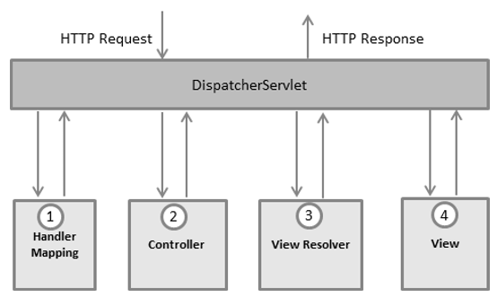
Following is the sequence of events corresponding to an incoming HTTP request to DispatcherServlet −
- After receiving an HTTP request, DispatcherServlet consults the HandlerMapping to call the appropriate Controller.
- The Controller takes the request and calls the appropriate service methods based on used GET or POST method. The service method will set model data based on defined business logic and returns view name to the DispatcherServlet.
- The DispatcherServlet will take help from ViewResolver to pickup the defined view for the request.
- Once view is finalized, The DispatcherServlet passes the model data to the view which is finally rendered on the browser.

